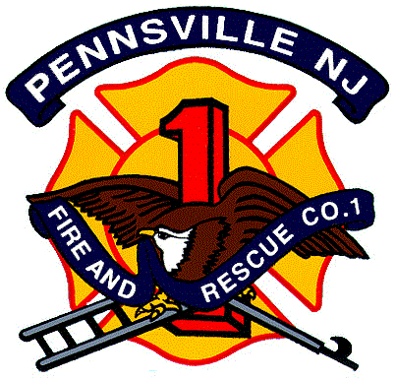Pennsville Fire & Rescue Co. 1
91 First St.
Pennsville, NJ 08070

Telephone (856) 678-5981
Fax (856) 678-8783

Dear Applicant,

On behalf of our membership, I wanted to thank you for your interest in joining with our organization and your desire to serve our community as a volunteer firefighter. This is the first step in what, for many is a very fulfilling journey.

Volunteering your time takes effort, dedication and commitment. As with any organization, there are certain requirements that you will be expected to fulfill and regulations that must be adhered to. We will ensure that you are made aware of all requirements and expectations.

Firefighting is a dangerous profession! While we as a department will provide you with all the necessary personal protective equipment and required training – each member must be aware that accidents may occur and injuries are possible at any given time. There will be unpleasant situations that you will encounter as an emergency responder.

We bring all of this to your attention not as a deterrent but to make sure that you have a
correct understanding about what you are joining. We are not a social club, but a vital organization whose primary function is to provide timely, efficient emergency services
in the safest manner possible.

With all of this said, joining our department has many benefits. All required equipment and training is paid for. You have free access to fitness equipment, will be issued required station apparel for stand-by functions, provided an opportunity to join the NJ Fireman’s Relief Association and be enrolled in the township L.O.S.A.P. (Length of Service Award Program).

In order for your application to be processed, it is required that you sign stating you have read and understand this letter. Applicants who do not meet our requirements and/or cannot complete initial membership process will not be processed for acceptance. This initial membership process is outlined on the back of this letter.

I look forward to meeting with you as you begin your career with our department and in serving your community.

Respectfully,

Larry Zimmerman, Chief
Pennsville Fire & Rescue Co. 1

PENNSVILLE FIRE & RESCUE Co. 1
Application Process

**Applications received will be read at the company meeting which is held first Wednesday of each month. All of the below is to be completed during the following month.

Fill Out and submit Application
- Must be completely filled out to include:
  - Acknowledgement of attached letter
  - Acknowledgement of fingerprints completed

Once contact by Membership Committee, Phase 1initial training will be scheduled
- Meet with Membership Committee
- Complete background and personal information form
- Phase 1 Classroom
  - Includes your expectations
  - What you can expect from us
  - Rules, regulations – S.O.G’s, By-Laws and House Rules
  - Officers and organizational structure

Training Certifications:
- Review of Engine 5-1 and Utility 5-7
  - Equipment location
  - Setting up of lighting and electrical equipment
  - Demonstrating hooking up hydrant
  - Apparatus riding positions and overview
- C.P.R. (if not already certified)
- Bloodbourne Pathogens (if not already completed)
- Right-to-Know (if not already completed)

Issuance and Review of Personal Protective Turn-Out gear

When ALL of the above is completed:

You will be recommended to be accepted as a Probationary Member
- Will be issued a pager
- Will be issued a station key
- Will be issued certain station apparel

